IRRIGATION_HYDRAULIC_PERFORMANCE SQL ANALYSIS.
create database irrigation_hydraulic_perf_db;
select * from 02_irrigation_hydraulic_performance;

-- CHANGE TABLE NAME
alter table `02_irrigation_hydraulic_performance` rename to `irrigation_hydraulic_performance`;

select * from irrigation_hydraulic_performance;

-- HOW MANY SCHEMES ARE IN THE DATASET
select distinct scheme from irrigation_hydraulic_performance;
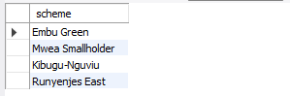
-- There are four schemes in this dataset.

-- HOW MANY BLOCKS DO THE SCHEMES SERVE
select distinct block from irrigation_hydraulic_performance;
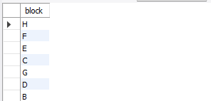
-- The four (4) schemes serve 8 distinct blocks.

-- TOTAL NUMBER OF OFFTAKES
select
sum(number_of_offtakes) as total_offtakes
from irrigation_hydraulic_performance;
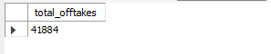
-- The total number of offtakes/members/farmers/beneficiaries is 41,884

-- NUMBER OF OFFTAKES PER SCHEME
select
scheme,
sum(number_of_offtakes) as offtakes_per_scheme
from irrigation_hydraulic_performance
group by 1
order by 2 desc;
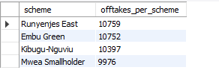
-- Runyenjes East irrigation scheme serves/ has the highest number of offtakes/members/farmers(10759).
-- Embu Green serves 10752 members/farmers/offtakes.
-- Kibugu_Nguviu serves 10397 members/farmers/offtakes.
-- Mwea Smallholder irrigation scheme serves/has the lowest number of offtakes/members/farmers(9976).

-- NUMBER OF OFFTAKES PER BLOCK
select
block,
sum(number_of_offtakes) as offtakes_per_block
from irrigation_hydraulic_performance
group by 1
order by 2 desc;
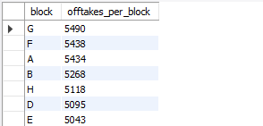
-- Block G has the highest number of offtakes/members/farmers(5490) while Block C has the lowest number of offtakes/members/farmers(4998).
-- Block F has 5438 offtakes, Block A 5434 offtakes, Block B 5268, Block H 5118 offtakes,Block D 5095 offtakes and Block E 5043 offtakes.

-- HOW MANY MEMBERS DOES EACH SCHEME SERVE IN EACH OF THE BLOCKS
select * from(
select
scheme,
block,
sum(number_of_offtakes) as members,
case
when block = 'A' then round((sum(number_of_offtakes) / '5434') * 100, 2)
when block = 'B' then round(( sum(number_of_offtakes) / '5268') * 100, 2)
when block = 'C' then round((sum(number_of_offtakes) / '4998') * 100, 2)
when block = 'D' then round(( sum(number_of_offtakes) / '5095') * 100, 2)
when block = 'E' then round(( sum(number_of_offtakes) / '5043') * 100, 2)
when block = 'F' then round(( sum(number_of_offtakes) / '5438') * 100, 2)
when block = 'G' then round(( sum(number_of_offtakes) / '5490') * 100, 2)
when block = 'H' then round((sum(number_of_offtakes) / '5118') * 100, 2) end as member_percentage_served_by_each_scheme_per_block,
rank() over(partition by block order by sum(number_of_offtakes) desc) as rnk
from irrigation_hydraulic_performance
group by 1,2)t;
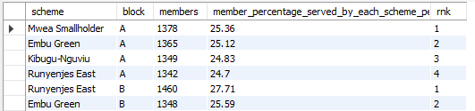
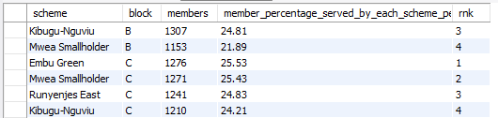
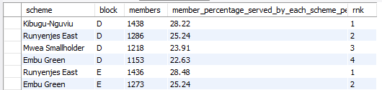
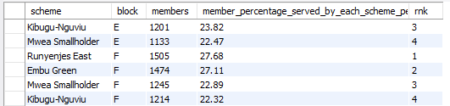
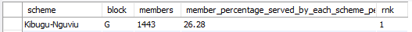
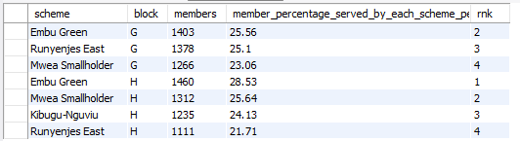

-- No scheme dominates any single block — every share falls within a 22–29% band, close to the 25% one would expect if the four schemes were evenly interleaved
-- In Block A, Mwea Smallholder serves the most members(25.36%) while Runyenjes East serves the least members(24.7%).
-- In Block B, Runyenjes East serves the most members(27.71%) while Mwea Smallholder serves the least members(21.89%).
-- In Block C, Embu Green serves the most members(25.53%) while Kibugu Nguviu serves the least members(24.21%).
-- In Block D, Kibugu Nguviu serves the most members(28.22%) while Embu Green serves the least members(22.63%).
-- In Block E, Runyenjes East serves the most members(28.48%) while Mwea Smallholder serves the least members(22.47%).
-- In Block F, Runyenjes East serves the most members(27.68%) while Kibugu Nguviu serves the least members(22.32%).
-- In Block G, Kibugu Nguviu serves the most members(26.28%) while Mwea Smallholder serves the least members(23.06%).
-- In Block H, Embu Green serves the most members(28.53%) while Runyenjes East serves the least members(21.71%).

-- AVERAGE FLOW
select
round(avg(flow_lps),2) as average_flow
from irrigation_hydraulic_performance;
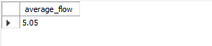
-- The average flow recorded in the dataset is 5.05 L/s.

-- MAXIMUM AND MINIMUM FLOW
select
round(max(flow_lps),2) as maximum_flow,
round(min(flow_lps),2) as minimum_flow
from irrigation_hydraulic_performance;
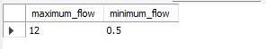
-- The maximum flow rate recorded in he dataset is 12 L/s while the minimum flow rate is 0.5 L/s.

-- WHAT IS THE AVERAGE FLOW FOR EACH OF THE SCHEMES
select
scheme,
round(avg(flow_lps),2) as average_flow_per_scheme
from irrigation_hydraulic_performance
group by 1
order by 2 desc;
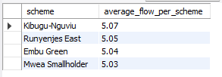
-- Kibugu-Nguviu has the highest average flow rate of 5.07 L/s while Mwea Smallholder has the lowest average flow rate of 5.03 L/s. Generally, the four schemes have a steady average flow of 5 L/s.

-- AVERAGE EXPECTED PRESSURE VS AVERAGE MEASURED_PRESSURE
select
round(avg(expected_pressure_m),2) as average_expected_pressure,
round(avg(measured_pressure_m),2) as average_measured_pressure
from irrigation_hydraulic_performance;
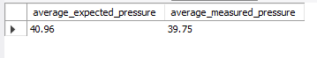
-- The average expected pressure from the dataset is 40.96m while the average measured pressure is 39.75m.

-- MAXIMUM AND MINIMUM MEASURED PRESSURE
select
round(max(measured_pressure_m),2) as maximum_measured_pressure,
round(min(measured_pressure_m),2) as minimum_measured_pressure
from irrigation_hydraulic_performance;
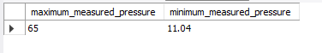
-- The maximum measured pressure was 65 while the minimum measured pressure was 11.04.
-- The 11.04 m minimum is far below the average expected pressure from the dataset of 40.96 m average and warrants a direct field check — in a static/dynamic head system that low a reading, if genuine, points to a tail-end deficiency, a partially closed valve, or a leak upstream of that chainage rather than ordinary friction loss.

-- WHATS THE AVERAGE EXPECTED PRESSURE AND AVERAGE MEASURED PRESSURE PER SCHEME
select
scheme,
round(avg(measured_pressure_m),2) as average_measured_pressure_per_scheme,
round(avg(expected_pressure_m),2) as average_expected_pressure_per_scheme,
round(avg(pressure_difference_m),2) as average_pressure_difference_per_scheme
from irrigation_hydraulic_performance
group by 1
order by 3 desc;
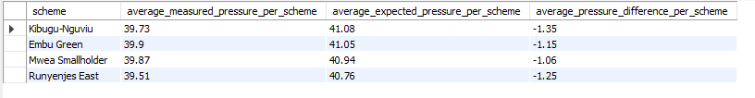
-- The comparison between average measured and expected pressure shows that all four irrigation schemes recorded lower measured pressures than the expected values(a consistent but relatively small pressure deficit). The pressure deficit ranged from -1.06 m to -1.35 m.
-- Kibugu–Nguviu recorded the largest deviation (-1.35 m), while Mwea Smallholder recorded the smallest (-1.06 m). Despite these differences, the deviations represent only approximately 2.6 – 3.3% of the expected pressures, indicating a relatively close agreement between the expected and actual hydraulic conditions. Overall, the results suggest that the four schemes are generally operating close to their expected pressure conditions, although the consistent negative deviation indicates some pressure losses within the systems that should be considered in assessing hydraulic performance.
-- Every scheme underperforms its expected pressure, and the ranking is consistent with the head-loss ranking: Kibugu-Nguviu has both the largest pressure deficit (-1.35 m) and the highest average head loss, while Mwea Smallholder has the smallest deficit (-1.06 m) and the lowest head loss.

-- AVERAGE HEADLOSS
select
round(avg(estimated_head_loss_m),2) as average_headloss
from irrigation_hydraulic_performance;
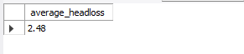
-- The average headloss is 2.48 m, it means that, on average, the water loses about 2.48 meters of hydraulic head/pressure (energy) due to friction and other losses as it flows through the system.

-- AVERAGE HEADLOSS PER SCHEME
select
scheme,
round(avg(estimated_head_loss_m),2) as average_headloss_per_scheme
from irrigation_hydraulic_performance
group by 1
order by 2 desc;
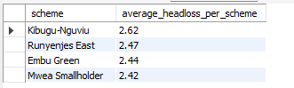

-- Kibugu Nguviu irrigation scheme has a higher average headloss than another, it generally means that more hydraulic energy (pressure/head) is being lost as water flows through that scheme.
-- The higher headloss indicates that Kibugu Nguviu experiences more resistance to flow. This can result from factors such as longer pipelines, smaller pipe diameters, higher flow rates, more bends, valves, fittings and connections, greater pipe roughness, Changes in elevation and pipeline configuration
-- The ranking is consistent with the pressure deficit ranking: Kibugu-Nguviu has both the largest pressure deficit (-1.35 m) and the highest average head loss, while Mwea Smallholder has the smallest deficit (-1.06 m) and the lowest head loss.

-- WHICH SCHEME HAS THE LONGEST PIPE LENGTH
select
scheme,
round(sum(pipe_length_m),2) as total_pipe_length_used
from irrigation_hydraulic_performance
group by 1
order by 2 desc;
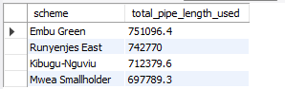
-- Embu Green has the longest cumulative network but is not the scheme with the most offtakes (that's Runyenjes East) or the highest head loss (that's Kibugu-Nguviu) — so pipe length alone does not explain hydraulic performance here. That points to pipe diameter and material mix mattering more than sheer network length, which is the expected result: a longer run in a correctly-sized larger-diameter pipe loses less head than a shorter run in an undersized one.

-- WHICH PIPE MATERIAL WAS USED THE MOST BY EACH OF THE SCHEMES
select
scheme,
pipe_material,
count(*) as number_of_records
from irrigation_hydraulic_performance
group by 1,2
order by 3 desc;
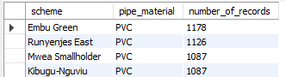
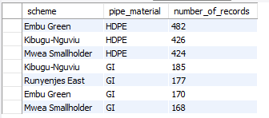
-- PVC is the dominant material in every one of the four schemes, in the same rank order (PVC > HDPE > GI) with near-identical proportions — a sign of a standardized design/procurement decision rather than material choice varying by local terrain or scheme budget. PVC's dominance is reasonable for gravity-fed smallholder irrigation (low cost, corrosion-free, easy to joint); GI is likely reserved for short high-stress sections (crossings, exposed above-ground runs, or connections near valves) where PVC would be more vulnerable to mechanical damage or UV exposure.

-- AVERAGE IRRIGATION DURATION PER SCHEME
select
scheme,
round(avg(irrigation_duration_hr), 2) as scheme_avg_irrigation_duration_hr
from irrigation_hydraulic_performance
group by 1
order by 2 desc;
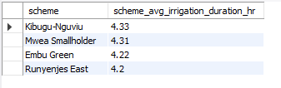
-- Generally, the four schemes offer an average of 4 hours of irrigation duration with Kibugu Nguviu offering the longest average irrigation duration of 4.33 hours.

-- AVERAGE IRRIGATION DURATION PER BLOCK
select
block,
round(avg(irrigation_duration_hr), 2) as avg_irrigation_duration_per_block_hr
from irrigation_hydraulic_performance
group by 1
order by 2 desc;
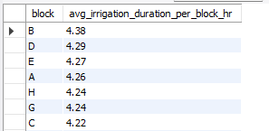

-- WHAT IS THE AVERAGE FLOW PER BLOCK
select
block,
round(avg(flow_lps), 2) as avg_flow_per_block_lps
from irrigation_hydraulic_performance
group by 1
order by 2 desc;
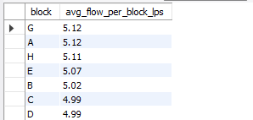
-- Scheduling is close to uniform. Irrigation duration is not being used as a compensating mechanism for the pressure/head-loss shortfalls found in Blocks A and F — those blocks aren't being given materially more time to make up for lower pressure, which is worth raising with scheme operators, since a modest, deliberate duration increase for underperfoming blocks is often a cheaper short-term fix than pipe replacement.

-- AVERAGE MEASURED PRESSURE VS AVERAGE EXPECTED PRESSURE PER BLOCK
select
block,
round(avg(measured_pressure_m), 2) as avg_measured_pressure_m,
round(avg(expected_pressure_m), 2) as avg_expected_pressure_m,
round(avg(pressure_difference_m), 2) as avg_pressure_difference_m
from irrigation_hydraulic_performance
group by 1
order by 4 asc;
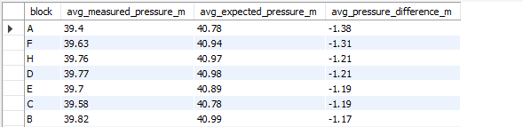

-- AVERAGE HEADLOSS PER BLOCK
select
block,
round(avg(estimated_head_loss_m),2) as avg_headloss_per_block
from irrigation_hydraulic_performance
group by 1
order by 2 desc;
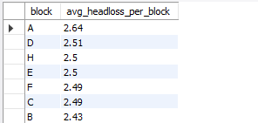
-- The higher the headloss in a system the higher the pressure deficit in the system.
-- Block A is the network's weakest performer: the largest pressure deficit (-1.38 m) paired with the highest average head loss (2.64 m), despite an average flow that isn't the network's highest. Block G is the strongest performer on both counts (-0.96 m deficit, 2.30 m head loss) even though it also carries the most offtakes— evidence that Block G's mainline is comparatively well-sized for its load, while Block A's is comparatively under-sized or under-maintained for its own. Block A is the clearest candidate for a physical pipe inspection (joints, partial blockage, or an undersized run) among the eight blocks.

HIGHEST HEAD-LOSS READINGS CHAINAGES PER BLOCK(FIELD-INSPECTION PRIORITY LIST)
select
scheme,
block,
chainage_m,
pipe_diameter_mm,
pipe_material,
flow_lps,
round(estimated_head_loss_m,2) as headloss_m,
round(pressure_difference_m,2) as pressure_deficit_m
from irrigation_hydraulic_performance
order by estimated_head_loss_m desc
limit 10;
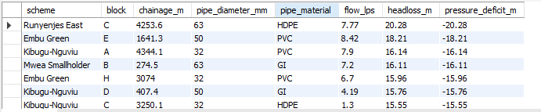
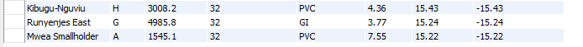

-- These ten readings sit far above the 2.48 m network average headloss and represent the single most useful output of this whole analysis for an operations team: a short, ranked list of exact points to physically inspect first, rather than a vague instruction to 'check the network.' Kibugu-Nguviu appears four times in the top ten (consistent with it having the highest scheme-average head loss), reinforcing it as the priority scheme for a walk-through inspection. Six of the ten worst readings are on 32mm pipe .

CHAINAGES MARKED WITH HIGH PRESSURE HYDRAULIC STATUS.
select
scheme,
block,
chainage_m,
pipe_diameter_mm,
measured_pressure_m,
expected_pressure_m,
pressure_difference_m,
hydraulic_status
from irrigation_hydraulic_performance
where hydraulic_status = 'High Pressure'
group by 1,2,3,4,5,6,7
order by 7 desc
limit 10;

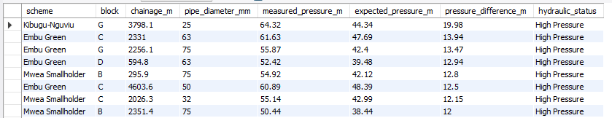

-- These ten readings represent another useful output of this analysis for an operations team: a short, ranked list of exact points to physically inspect first, rather than a vague instruction to 'check the network the high pressure points/chainages because over-pressurization, risk of pipe stress, joint failure, or blown fittings are very likely to occur at these chainages.

